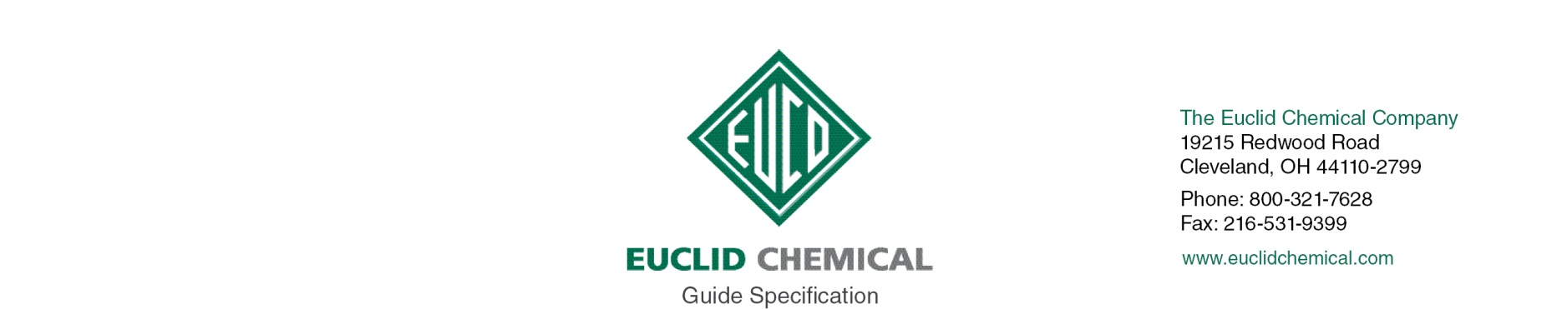
DURAL 452 GEL EPOXY
High Modulus, Gel Epoxy Bonding Adhesive

DURAL 452 GEL EPOXY is a two component, 100% solids material designed as a moisture insensitive adhesive for non-sag applications.

{Note to Specifier: The paragraphs below are meant to be incorporated into Parts 2 and 3 of a standard CSI 3 Part Format specification, project’s General Structural Notes or directly onto the plans. They must be carefully reviewed by a qualified design professional and edited to meet the particular requirements of the project at hand, assure compliance with any governing building codes, and coordinate with other specification sections and drawings.}

PART 2: PRODUCT

2._ EPOXY ADHESIVE

A. Two component, high modulus, pre-proportioned, moisture insensitive, VOC compliant, 100% solids epoxy adhesive. Products shall conform to:
ASTM C 881 Types I, II, IV, and V, Grade 3, Class C.
Material shall have the following properties:
1. Minimum 10,000 psi Compressive Strength
2. Minimum 2,800 psi Bond Strength
3. Product:
- Euclid Chemical Company (The); Dural 452 Gel Epoxy
- www.euclidchemical.com

B. Manufacturer shall have ISO 9001 Quality Certification. To ensure compatibility repair mortar and curing compound shall be from the same manufacturer.

{Note to Specifier: This product is also suitable for horizontally aligned dowel bars.}

PART 3: EXECUTION

3._ EXAMINATION

A. Examine concrete surfaces to receive epoxy bonding agent. Notify Engineer if surfaces are not acceptable. Do not begin surface preparation or application until unacceptable conditions are corrected.

3._ SURFACE PREPARATION

A. Concrete Removal: Remove all loose and unsound concrete per ICRI Guideline 310.1R “Guide for Surface Preparation”.

B. Preparing Reinforcing Steel: Clean and prepare embedded reinforcing steel per ICRI Guideline 310.1R.
1. Where 1/2 or more of the diameter of the reinforcement steel is exposed either by existing conditions or concrete removal, the bond between the concrete and the reinforcing steel is broken, or corrosion is present the concrete shall be removed to provide a minimum 3/4 inch clearance around the entire perimeter of the steel and along the entire exposed length.
2. Clean all exposed reinforcing steel to bright steel, prior to installation of repair mortar.
- If section loss of a reinforcing bar is more than 25% or 20% in two or more adjacent bars contact Engineer.

C. Concrete Preparation and Cleaning: Areas to receive concrete repair shall be structurally sound and free from deteriorated concrete, dust, dirt, paint, oil, efflorescence, laitance, and other contaminants, and shall have a Concrete Surface Profile (CSP) equal to that recommended by the repair mortar manufacturer per ICRI Guideline 310.2R.

D. Clean surface using un-oiled compressed air or vacuum clean.

3._ APPLICATION

- Mix and place epoxy adhesive in accordance with manufacturer’s written instructions.

- Place concrete or repair mortar over epoxy adhesive within the maximum allowable time.

- Follow manufacturer’s recommendations for reinforcing rod embedment depth and hole diameter.

