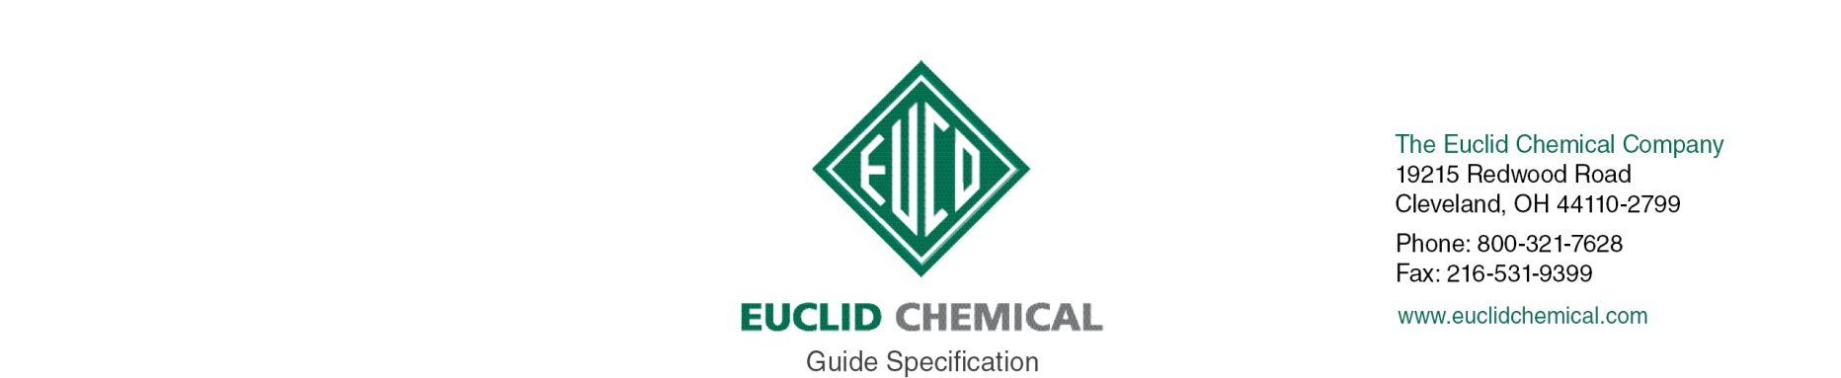
EUCOPOXY TUFCOAT

Two part solvent-based epoxy floor coating providing semi-gloss appearance.

{Note to Specifier: The paragraphs below are meant to be incorporated into Parts 2 and 3 of a standard CSI 3 Part Format specification, project’s General Structural Notes or directly onto the plans. They must be carefully reviewed by a qualified design professional and edited to meet the particular requirements of the project at hand, assure compliance with any governing building codes, and coordinate with other specification sections and drawings.}

PART 1 GENERAL

{Note to Specifier: Euclid Chemical recommends that the following language be added to Part 1 of your specification section discussing Resinous Flooring.}

A. Obtain primary resinous flooring materials, including primers, from resinous flooring manufacturer. Obtain secondary materials including aggregates, sheet flashings, joint sealants, and substrate repair materials of type and from source recommended by resinous flooring manufacturer.
1. Resinous flooring manufacturer shall have ISO 9001 Quality Certification.

B. Resinous Flooring Mock-Up:
- Prior to commencing resinous flooring application, prepare a minimum <<insert size>> full scale, reference mock-up of each type, [and][color][and][texture] of resinous flooring surface for approval by Owner. Said reference mock-up shall be constructed in location designated by owner/architect, using the same equipment, tools and methods for installing all materials as will be used for the remaining work to be performed.
- Once accepted by owner or owner’s representative, mock-up is to remain, and is to be protected from damage. It shall become the standard for acceptance of color and texture for resinous flooring applications.
- When Architect determines that mockup does not meet requirements, demolish and remove it from the site and cast another until the mockup is accepted.

1.02 PROJECT CONDITIONS

A. Environmental Limitations: Apply resinous flooring within the range of ambient and substrate temperatures recommended in writing by manufacturer. Do not apply resinous flooring to damp or wet substrates, when temperatures are below 50 deg F (5 deg C), when relative humidity exceeds 70 percent, or when temperatures are less than 5 deg F (-15 deg C) above dew point.
1. Coordinate flooring work with other trades to ensure adequate illumination, ventilation, and dust free environment during application and curing of flooring.

B. Conditions for Concrete

{Note to Specifier: New concrete slabs on grade to to receive resinous floor coating should be poured over heavy duty, uninterrupted, properly installed, vapor barrier.}

{Note to Specifier: : Moisture retaining cover cure is to be removed after seven days to allow the concrete to air dry prior to flooring installation.}

1. New concrete shall be cured a minimum of 7 days, and in place a minimum 28 days before proceeding.
2. Any cementitious repair mortars must have a full 7-day cure prior to coating.
3. Examination:
- Prior to commencement of resinous floor system application examine substrates, with Applicator present, for compliance with requirements and for other conditions affecting performance of resinous flooring.
- For the record, prepare written report, endorsed by Applicator, listing conditions detrimental to performance.
- Verify compatibility with and suitability of substrates.
- Contractor must report, in writing, surfaces left in improper condition by other trades. Application of coating indicates acceptance of surfaces and conditions.

PART 2.0 PRODUCT

2.__ RESINOUS FLOOR SYSTEM

A. Epoxy Floor Coating: (2) component, solvent based, epoxy floor coating with the following characteristics;
1. Minimum Solids Content: 58%
2. VOC Content: 418 g/l
3. Taber Abrasion CS17 Wheel, 1000 g load, 500 cycles; 30.2 mg loss (maximum)
4. Product:
- Euclid Chemical Company (The); Eucopoxy Tufcoat, www.euclidchemical.com
- Color: [To be chosen from manufactures list of standard colors][Black][Clear Amber][Concrete Gray][Light Reflective][Tile Red][White]

PART 3.0 EXECUTION

3.___ SURFACE PREPARATION

A. Clean and mechanically prepare substrates according to manufacturer’s written recommendations to produce clean, sound, dust-free, dry, absorptive substrate free of grease, oils, curing compounds and other contaminants which may interfere with bond of resinous flooring. Surface profile should be equal to CSP 2 to 5 in accordance with ICRI Guideline 310.2.
1. Following surface preparation the cleaned concrete floor shall be tested for compliance with the following:
- Minimum surface tensile strength of 200 psi when tested with an “Elcometer” or similar pull tester per ASTM D 4541.
- No vapor drive condition present when tested in accordance with ASTM F 1869 “Calcium Chloride Test”
2. Begin resinous flooring application only after minimum concrete curing and drying period recommended by resinous flooring manufacturer has passed, after unsatisfactory conditions have been corrected, and after surfaces are dry

B. Prepare vertical and horizontal surfaces at terminations and penetrations through resinous flooring and at expansion joints, drains, and sleeves according to manufacturer’s written recommendations

C. Mask adjoining surfaces not receiving resinous flooring, drains, and other substrate
penetrations to prevent spillage, leaking, and migration of coatings.

3.___ RESINOUS FLOOR SYSTEM APPLICATION:

A. Resinous Floor System Monolithic Coating Applicaton:
1. Mechanical Mixing- Coating and primers shall be thoroughly mixed with a mechanical drill with a manufacturer approved mixing blade. Premix individual components separately per manufacturer’s recommendations then combine materials and mix per manufacturers recommendations. Bottom and sides of container may be scraped during mixing but shall not be scraped once mixing has ceased. Do not aerate material.
2. Epoxy Floor Coating: Apply uniform application of properly mixed urethane floor coating to floor per manufacturer’s written recommendations at recommended coverage rates. Allow 4 to 6 hours but no more than 24 hours before applying additional coats. [Repeat for second coat.]

{Note to Specifier: Depending on the specific project, correct implementation of other application details, such as floor terminations, floor/drain detail, etc. may be required. For further information contact Euclid Chemical Technical Support at (800) 321-7628.}

3.__ CURING AND PROTECTING

A. Prevent contamination and damage during application and curing stages.

B. Protect resinous flooring from damage and wear during remainder of construction period.

