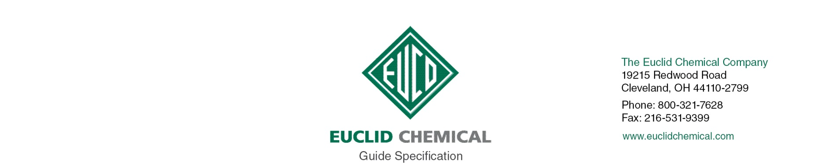
DIAMOND HARD
Cast-In-Place Concrete

{Note to Specifier: This add-in specification component specifies Euclid Chemical Company, Diamond Hard Liquid Densifier and Sealer for Concrete}

EUCO DIAMOND HARD sealer is unique blend of silicate and siliconate polymers that penetrate concrete surfaces and chemically react to provide an increase in surface density, durability and abrasion resistance.

{Note to Specifier: The paragraphs below are meant to be incorporated into Parts 2 and 3 of a standard CSI 3 Part Format specification, project’s General Structural Notes or directly onto the plans. They must be carefully reviewed by a qualified design professional and edited to meet the particular requirements of the project at hand, assure compliance with any governing building codes, and coordinate with other specification sections and drawings.}

1.1 QUALITY REQUIREMENTS

A. Manufacturer: ISO 9001 quality certified as primary manufacturer of specified products.

1.2 INFORMATIONAL SUBMITTALS

A. Product List: List manufacturer name and product name for each product proposed for

use as concrete admixture and surface treatment.

B. Manufacturer Certificate: Indicating products listed on Contractor's Product List are compatible and suitable for the specified application.

PART 2 PRODUCTS

2.1 MANUFACTURERS

A. Manufacturer: Provide listed products of Euclid Chemical Co., Cleveland, OH;

www.euclidchemical.com.

B. Manufacturer Single Source: Provide liquid densifier sealer and related concrete

treatment and admixture products from a single qualified manufacturer.

2.2 LIQUID FLOOR TREATMENTS

A. Liquid Densifier Sealer: High performance, deeply penetrating concrete densifier;

odorless, colorless, VOC - compliant, non-yellowing silicate and siliconate based solution designed to harden, dustproof and protect concrete floors and to resist black rubber tire marks. The compound must contain a minimum solids content of 20% of which 50% is siliconate.

1. Product:
- Basis of Design Product: “Euco Diamond Hard” by The Euclid Chemical Co. www.euclidchemical.com

PART 3 EXECUTION

3.1 EXAMINATION

{Note to Specifier: Retain this Article when applying liquid densifier sealer to existing concrete surfaces.}

[A. When used on existing concrete, examine concrete surfaces to receive liquid

densifier sealer. Notify specifier if surfaces do not comply with manufacturer's recommendations. Do not begin surface preparation or application until unacceptable conditions are corrected]

3.2 PREPARATION

A. When used on existing concrete, prepare concrete surfaces in accordance with

manufacturer’s written instructions.

1. Ensure surfaces are clean, dry and free of standing water.

2. Remove dirt, dust, oil, grease, sealers, and other materials that may prevent

penetration liquid densifier sealer.

3.3 APPLICATION

A. Apply Liquid Densifier Sealer in strict accordance with the directions of the manufacturer.

Spray, squeegee or roll on liquid to clean, dry concrete surface at a rate no greater than 225 sq. ft. per gallon. The liquid shall be scrubbed into the surface with a mechanical scrubber. Keep the surface wet for a minimum of 30 minutes with the Liquid Densifier Sealer during the application process. When the product thickens, but not more than 60 minutes after initial application, the surface shall then be squeegeed or vacuumed to remove all excess liquid.

1. Do not leave any residue on surface.

2. Do not track material on to untreated surfaces.

