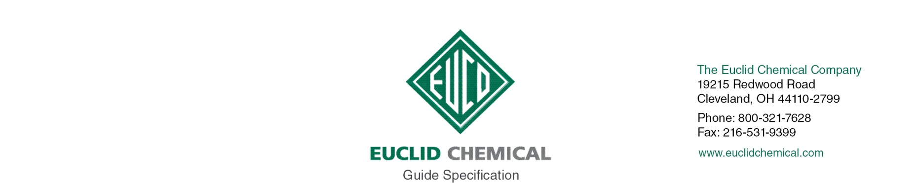
TAMMSBAR
Rebar Touch-Up Epoxy Coating

{Note to Specifier: The paragraphs below are meant to be incorporated into Part 2 of a standard CSI 3 Part Format specification (normally 03 30 00), the General Structural Notes, or directly onto the plans. They must be carefully reviewed and edited by a qualified design professional to meet the requirements of the project and governing building codes. Coordinate with other specification sections and drawings.}

PART 2: PRODUCTS

{PRODUCT}

2.__ PRODUCT

A. Rebar Touch-up Epoxy Coating: Two-Part Ambient Temperature Cure Thermosetting Liquid Epoxy Coating.
1. Mix Ratio (By Volume): 1:1
2. Mixed Viscosity: 1500 cps
3. Gel Time: 45 to 60 minutes
4. Tack Free Time: 4 to 5 hours
5. VOC Content: < 50 g/L

{ISO AND SINGLE SOURCE}

2.__ MANUFACTURER

A. Manufacturer shall have ISO 9001 Quality Certification. To ensure compatibility all products shall be from the same manufacturer.

PART 3: EXECUTION

{PREP}

3.__ SURFACE PREPARATION

A. Prepare surfaces in accordance with manufacturer’s written instructions.

B. Steel surfaces shall be clean, dry, free of all oil, grease, dust, scale, rust, damaged coating from repair area and any other contaminants that my interfere with adhesion.

4.__ MIXING

A. Premix Part A and Part B separately then combine one part of part A with one part of part B in a clean, dry, container. Scrape the sides of the mixing container at least once during the mixing. Mix until uniform. Do not aerate during mixing. Mix only the quantity of material that can b used with its pot life.

5.__ APPLICATION

A. For best results the ambient and surface temperature should be above 50 degrees F (10 degrees C). Minimum application temperature is 40 degrees F (4 degrees C). Apply by brush, roller or standard spray or airless spray equipment. Apply to rebar, completely covering the defective area by overlapping onto existing powder coating. Allow to dry.

{CLEANUP}

A. Remove debris related to application from project site per applicable regulations for hazardous waste disposal.

{PROTECTION}

A. Protect work from contaminating substances and damage resulting from other construction operations or other causes so that the treated areas are without deterioration or damage at time of project completion.

