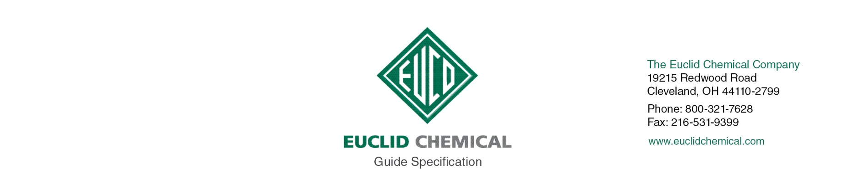
DURALFLEX FASTPATCH
Low Modulus Epoxy Repair Kit

{Note to Specifier: The paragraphs below are meant to be incorporated into Parts 2 and 3 of a standard CSI 3 Part Format specification, project’s General Structural Notes or directly onto the plans. They must be carefully reviewed by a qualified design professional and edited to meet the particular requirements of the project at hand, assure compliance with any governing building codes, and coordinate with other specification sections and drawings.}

PART 2.0: PRODUCT

2.__ EPOXY REPAIR MORTAR

A. Three component, 100% solids low modulus epoxy repair mortar with the following properties:
1. Compressive Strength psi(MPa):
75 Deg F 40 Deg F.
18 hours 7,000 (48.7) 4,000 (27.6)
3 days 9,400 (64.8) 6,800 (46.9)
7 days 9,800 (67.6) 8,000 (55.1)
2. Tensile Strength: 2,700 psi minimum per ASTM D 638
3. Flexural Strength: 3,600 psi minimum per ASTM C 580
4. Tensile Elongation: 45%
5. Shore D Hardness of minimum 85 per ASTM D 2240
6. Product:
a) Euclid Chemical Company (The); Duralflex Fastpatch, www.euclidchemical.com

B. Manufacturer shall have ISO 9001 Quality Certification. To ensure compatibility all admixtures shall be from the same manufacturer.

C. To ensure compatibility bonding agent and curing compound if used shall be from same manufacturer as repair mortar.

PART 3.0: EXECUTION

3.___ SURFACE PREPARATION

{CONCRETE REMOVAL NOTE}

A. Concrete Removal: Remove all loose and unsound concrete per ICRI Guideline 310.1R “Guide for Surface Preparation”
1. Unsound concrete surface areas shall have perimeter boundaries saw cut to minimum depth of ¼ inch or less if such depth will cause saw to come in contact with embedded reinforcing steel. Saw cuts shall be made perpendicular to the concrete surface and all concrete removal boundaries shall be straight and aligned parallel to opposite boundary edges resulting in repair areas that are rectangular in shape.
2. All concrete shall be removed from within repair boundary to minimum depth of ¼ inch. Provide a surface with suitable profile for bond, as defined in repair mortar manufacturer’s written recommendations. If delaminations, cracking, or unsound materials exist beyond minimum removal depth, then removal shall continue until all unsound, delaminated, or cracked concrete has been removed from cavity.

B. Preparing Reinforcing Steel: Clean and prepare any exposed embedded reinforcing steel per ICRI Guideline 310.1R. “Guide for Surface Preparation”
1. Where ½ or more of diameter of reinforcement steel is exposed either by existing conditions or concrete removal, bond between the concrete and reinforcing steel is broken, or corrosion is present, the concrete shall be removed to provide a minimum ¾” clearance around entire perimeter of steel and along entire exposed length.
2. Clean all exposed reinforcing steel to bright steel, prior to installation of repair mortar.
a) Where section loss on a reinforcing bar is more than [insert number]%, or [insert number]% in two or more adjacent bars contact Engineer.

C. Concrete Preparation and Cleaning: Areas to receive concrete repair shall be structurally sound and free from deteriorated concrete, dust, dirt, debris, loosened concrete, paint, oil, efflorescence, laitance, and other contaminants, and shall have a minimum Concrete Surface Profile CSP equal to that recommended by the repair mortar manufacturer per ICRI Guideline 310.2.

3.___ EPOXY REPAIR MORTAR APPLICATION:

A. Repair Mortar Trowel Applied: Mix and apply Repair Mortar per manufacturer’s recommendations. Finish to level of surrounding concrete surface utilizing techniques recommended by manufacturer.

