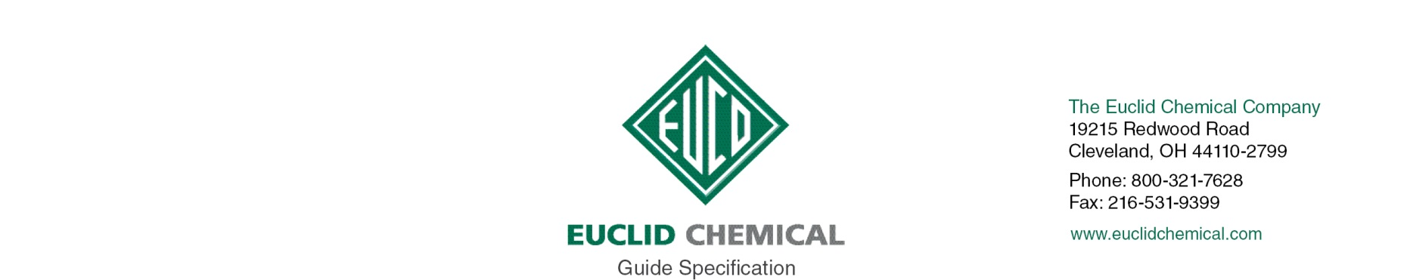
EUCON BARACADE WPT
Integral Water Repellent Admixture

EUCON BARACADE WPT is a high-performance liquid water repellent admixture used to improve the durability and surface integrity of concrete exposed to harsh weather conditions. By resisting moisture and chloride ion penetration, concrete produced with EUCON BARACADE WPT reduces the potential for scaling, spalling, and other moisture-related degradation. The visual appeal of decorative concrete can also be improved by using EUCON BARACADE WPT to decrease the potential for secondary efflorescence. Unlike topically applied sealers, EUCON BARACADE WPT produces a chemically bonded and insoluble protection mechanism throughout the concrete mix. When concrete is produced with EUCON BARACADE WPT, capillary pores become resistant to water penetration making it less susceptible to freeze-thaw and deicing salt related damage as long as the concrete is properly air entrained. EUCON BARACADE WPT contains no added chlorides or chemicals known to promote the corrosion of steel.

{Note to Specifier: The paragraphs below are meant to be incorporated into Parts 2 and 3 of a standard CSI 3 Part Format specification, project’s General Structural Notes or directly onto the plans. They must be carefully reviewed by a qualified design professional and edited to meet the particular requirements of the project at hand, assure compliance with any governing building codes, and coordinate with other specification sections and drawings. In no case shall these Guide Specifications be considered to be Contract Documents or serve as installation instructions for the product being discussed. In any cases of discrepancy the manufacturer's most recently published data sheet shall take precedent.}

PART 1.0 GENERAL

1.01 RELATED WORK:

A. Joint Fillers – Eucolastic, Tammsflex, Dural 340, Qwikjoint UVR
B. Concrete Repair:
1. Vertical and Overhead: Euco V-100, Tamms Structural Mortar
2. Horizontal: Express Repair, VersaSpeed
3. Form and Pour: Eucocrete
C. Crack Repair/Injection: Dural 452 LV, Dural Fast Set Epoxy Gel
D. Bonding Agents: Eucoweld 2.0, Duralprep A.C., Dural 452 MV, EucoFloor Epoxy Primer
E. Waterproofing/Dampproofing : Tamoseal, Vandex Super, Hey’Di K-11, Vandex BB75
F. Architectural Coatings: Tammscoat, Tammolastic
G. Anti-Graffiti Coatings: AG 100, AG-400,
H. Traffic Deck Coatings: Tammsdeck, Flexdeck
I. Decorative Floor Coatings: Duraltex
J. Epoxy Chemical Resistant Coatings: Duralkote 240, Duralkote 500, Duraltex 1705/07, Duraltex 1805/07
K. Penetrating Water Repellents:
1. Horizontal and Vertical: Baracade Silane 40 WB, Baracade WB 244, Baracade 100C, Baracade Silane 40 IPA,
2. Vertical: Chemstop WB Regular/Heavy Duty
L. Penetrating Epoxy Sealer: Euco #512 VOX Epoxy Sealer
M. Cathodic Protection: Sentinel Galvanic Anodes

PART 2.0 PRODUCTS

2.__ CONCRETE ADMIXTURES

A. Integral Weatherproofing Admixture: Provide integral weatherproofing admixture designed to reduce intrusion of water and deicing chemicals into concrete, increase resistance to weathering, improve color retention and to reduce potential for efflorescence.

1. Basis of Design Product:
- Euclid Chemical Company (The); BARACADE WPT, www.euclidchemical.com

B. Manufacturer shall have ISO 9001 Quality Certification.

2.___ CURING MATERIALS

{Note to Specifier: Proper curing of the concrete is essential. Any curing compounds used should be applied as early as possible after finishing.

If a curing compound is intended the specifier should insert language for one of Euclid Chemical’s liquid curing or cure and seal compounds. Otherwise,insert language for proper ACI 308 curing methods. Duration of such cure should be minimum 7 days.}

END GUIDE SPEC

