
E³-HCR, HIGHLY CHEMICAL RESISTANT EPOXY GROUT
With Patent Pending DL TechnologyTM

{Note to Specifier: This add-in specification component specifies Euclid Chemical Company, E3-HCR Epoxy Grout. E3-HCR, highly chemical resistant epoxy grout is formulated from a special resin technology and a proprietary, patent pending, dustless DL TechnologyTM aggregate blend which is the new performance standard for epoxy grouts. E3-HCR has high compressive strength, with ultra-low creep and outstanding Effective Bearing Area (EBA) properties.}

{Note to Specifier: The paragraphs below are meant to be incorporated into Parts 2 and 3 of a standard CSI 3 Part Format specification, project’s General Structural Notes or directly onto the plans. They must be carefully reviewed by a qualified design professional and edited to meet the particular requirements of the project at hand, assure compliance with any governing building codes, and coordinate with other specification sections and drawings.}

PART 1 GENERAL

{Note to Specifier: Insert the following paragraph and sub paragraphs as required for your project. Euclid’s recommended products are shown in italics. More info can be found on these products at www.euclidchemical.com or by clicking on the product links.}

1.1 RELATED WORK:

A. Joint Fillers – Eucolastic, Tammsflex, Dural 340, Qwikjoint UVR
B. Concrete Repair:
1. Vertical and Overhead: EucoRepair V-100, Tamms Structural Mortar
2. Horizontal: Express Repair, VersaSpeed 100
3. Form and Pour: Eucocrete
C. Crack Repair/Injection: Dural 452 LV, Dural Fast Set Epoxy Gel
D. Bonding Agents: Duralprep A.C., Dural 452 MV
E. Waterproofing/Dampproofing : Tamoseal, Vandex Super, Hey’Di K-11, Vandex BB75
F. Architectural Coatings: Tammscoat, Tammolastic
G. Anti-Graffiti Coatings: AG 100, AG-400,
H. Traffic Deck Coatings: Tammsdeck, Flexdeck
I. Decorative Floor Coatings: Duraltex
J. Epoxy Chemical Resistant Coatings: Duralkote 240, Duralkote 500, Duraltex 1705/07, Duraltex 1805/07
K. Penetrating Water Repellents:
1. Horizontal and Vertical: Baracade WB 244, Baracade 100C, Baracade Silane 40 IPA
2. Vertical: Chemstop WB Regular/Heavy Duty
L. Penetrating Epoxy Sealer: Euco #512 VOX Epoxy Sealer
M. Cathodic Protection: Sentinel Galvanic Anodes

1.2 QUALITY REQUIREMENTS

A. Manufacturer: ISO 9001 quality certified as primary manufacturer of specified products.

1.3 INFORMATIONAL SUBMITTALS

A. Product List: List manufacturer name and product name for each product proposed for use as epoxy grout.

B. Manufacturer Certificate: Indicating products listed on Contractor's Product List are compatible and suitable for the specified application.

1.4 DELIVERY, STORAGE AND HANDLING:

- All materials shall be delivered to the jobsite in their original, unopened packages, clearly labeled with the manufacturer’s identification, printed instructions and batch numbers.

- Store and condition the specified product in accordance with the appropriate product data sheets.

- For handling instructions, refer to the Material Data Sheet.

PART 2: PRODUCTS

2.1 MANUFACTURERS

A. Manufacturer: Provide listed products of Euclid Chemical Co., Cleveland, OH; www.euclidchemical.com.

B An acceptable product that meets these criteria is:
E3-HCR, with DL Technology manufactured by The Euclid Chemical Company, 19218 Redwood Rd., Cleveland, OH 44110, (800)-321-7628.

C. Manufacturer Single Source: Provide epoxy grout products from a single qualified manufacturer.

2.2 EPOXY GROUT

A. Epoxy Grout: High Chemical Resistant epoxy grout.
1. Basis of Design Product:
a) “E3-HCR with DL TechnologyTM” by The Euclid Chemical Company
b) Appearance- Gray

c) Compressive Strength, ASTM C579, 2 in. (5 cm) cubes @ 70ºF (21ºC):
1) 1 day: 15,000 psi (104.2 MPa)
2) 7 days: 17,000 psi (118.1 MPa)
3) 28 days: 19,500 psi (135.4 MPa)
4) Post Cured: 20,000 psi (139 MPa)

d) Compressive Creep, ASTM C1181, 400 psi (2.8 MPa) @140 ºF (60ºC), 28 days
1) 2.3 x 10⁻³ in./in/ ºF. (mm/mm)

e) Coefficient of Thermal Expansion, ASTM C531, (73 to 210 ºF) (23 to 99ºC), 7 days:
1) 3.1 x 10⁻⁵ in./in./ ºF

f) Flexural Strength, ASTM C580:
1) 1 day: 5,400 psi (37.5 MPa)
2) 7 days: 5,700 psi (39.6 MPa)
3) 28 days: 5.750 psi (40.0 MPa)
4) Post Cured: 5,800 psi (40.3 MPa)

g) Tensile Strength, ASTM C307:
1) 1 day: 2,400 psi (16.7 MPa)
2) 7 days: 2,450 psi (17.0 MPa)
3) 28 days: 2,500 psi (17.4 MPa)
4) Post Cured: 2,550 psi (17.7 MPa)

h) Working Time, ICRI Protocol:
1) 34 minutes @ 73ºF (23ºC)

i) Peak Exotherm, ASTM D2471:
1) 155ºF (68.3ºC) @ 125 minutes

j) Effective Bearing Area, ASTM C 1339:
1) >95%

k) Bond to Concrete, ASTM C 882:
1) 7 days: 3,200 psi (22.2 MPa)
2) 28 days: 3,350 psi (23.3 MPa)

l) Chemical Resistance:
1) Excellent resistance to most industrial chemicals.

2.3 AGGREGATE REDUCTION

A. Aggregate content of the epoxy grout shall not be reduced beyond manufacturer’s recommendations.

PART 3: EXECUTION

{Note to Specifier: This section covers surface preparation, form preparation, mixing, placement, curing, and cleanup for Euclid Chemical’s E3-HCR Epoxy Grout. For complete current instructions and safety information, consult the Technical Data and Material Safety sheets posted at www.euclidchemical.com.}

3.1 SURFACE PREPARATION

A. Base Concrete:
1. New concrete must be a minimum of 28 days old, unless otherwise approved by the manufacturer. The concrete must be clean and rough. All oil, dirt, debris, paint and unsound concrete must be removed. The surface must be prepared mechanically using suitable equipment to give a surface profile of at least a CSP 5-7 in accordance with ICRI Guideline 310.2, exposing the coarse aggregate of the concrete. The final step in cleaning shall be the complete removal of all dust and residue with a pressure washer and then vacuum until all water is gone. Allow the concrete to completely dry. All concrete must possess an open surface texture with all curing compounds and sealers removed. When used on existing concrete, prepare concrete surfaces in accordance with manufacturer’s written instructions.

B. Base plate preparation:
1. Abrasive blast metal base plates to a commercial finish (SSPC-SP6) to enhance bond. Apply grout immediately to prevent re-oxidizing.
2. Where bond to metal surfaces is not required, coat with a bond breaker such as paste wax or duct tape.
3. Provide ¼ to ½ inch (6 to 12 mm) air relief holes where baseplate configuration will entrap air.
4. When grouting skid mounted equipment or frames, provide a 4 to 6 inch diameter (100 to 150 mm) grout filling hole in the center of each bulkhead section.
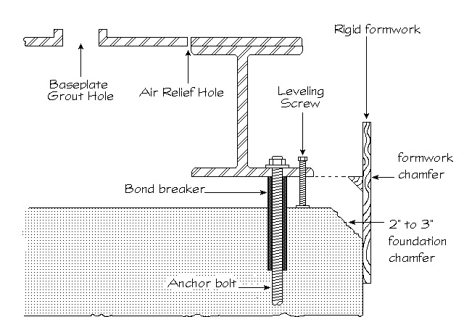
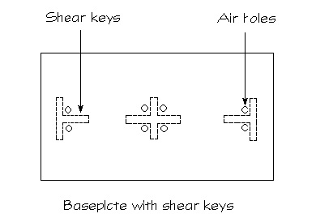

Figure 1 Figure 2

C. Anchor Bolt Holes and Blockouts:
1. Holes and blockouts shall be cleaned of all dust, dirt and debris and allowed to dry. If the sides are smooth, roughen the hole with a stiff bristle wire brush or with a rotary brush hammer if access permits.

3.2 FORM PREPARATION

- Forms must be liquid tight to prevent leakage and properly braced. To facilitate stripping, the forms shall be coated with two applications of a paste wax or each form wrapped with polyethylene. Care should be taken not to contaminate grouting surfaces where bond is required.

- Forms shall be set a minimum of one inch (25 mm) above the bottom of the baseplate. See figure 3.

- Formwork shall be constructed so that the grout is placed across the shortest distance whenever possible. The clearance between formwork and the baseplate shall be adequate to allow for the headbox. The clearance for the remaining sides shall be one to three inches (25-75mm).
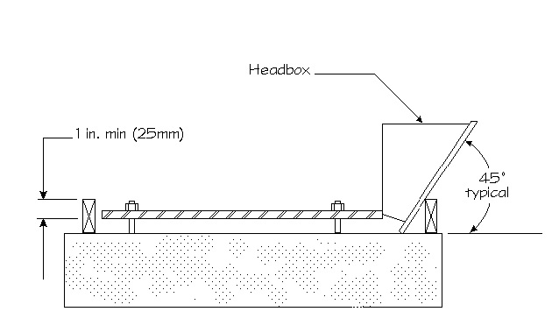

Figure 3

- Grout forms shall have one inch (25 mm) chamfer strips at all vertical corners and top edges of grout shoulders. See figure 1.

3.3 ENVIRONMENTAL CONDITIONS

- Condition and maintain materials to between 70ºF and 80ºF (21ºC and 27ºC) and all surfaces that contact grout between 60ºF and 90ºF (15ºC and 32ºC).

3.4 MIXING

Mortar Mixer with Stationary Barrel with Moving Paddles

- Always use at least one-half the capacity of the mixer when mixing the grout.

B. Pour component B (hardener) into the pail containing Component A (base). Mix with a “Jiffy” paddle on a variable speed drill at slow speed. The epoxy must be well mixed to ensure proper chemical reaction. Avoid air entrapment. After the epoxy has been mixed, immediately pour all contents into the mortar mixer. While mixing at slow speed, slowly add Component C (aggregate) without delay and mix only until aggregate is completely wet out. Place immediately.

3.5 PLACEMENT PROCEDURES

A. The grout must be placed without interruption. Should a delay occur that could last longer than the working time of the grout, all equipment used in the mixing and placing of the grout should be cleaned.

B. A headbox or similar device is required for a continuous pour to avoid air pockets under the baseplate. All grouting shall be placed from one side to the other, maintaining contact with the bottom of the baseplate at all times, maximizing effective bearing area.

C Start pouring grout from one end across the short dimension and work down the longer side as the material fills under the baseplate. In some situations, pre-placed straps under the baseplate aid in working the grout across to the other side.

D. When pouring through grout holes, placement shall proceed continuously with a headbox until the grout has risen in the next hole. Maintain head pressure at initial hole so that grout stays in contact with the bottom of the baseplate at all times. Commence grouting at the next hole with an additional headbox. Continue process, alternating headboxes until grouting is complete.

E. Headboxes shall be kept at least half full and filled in a manner to avoid air entrapment. If necessary to assist the flow, a plunger may be used. This process shall continue until the grout rises above the bottom edge of the baseplate on the other side.

F. Throughout the pour, forms shall be constantly checked for leaks. All leaks shall be sealed immediately.

3.6 FINISH

A. If a smooth finish is desired, the surface of the grout may be brushed and troweled with a light application of EUCO SOLVENT.

3.7 CURING

- Epoxy grout requires no special curing procedures.

- Protect grout from temperature extremes, rain and water after placement for at least 24 hours.

- The grout shall be protected from temperatures below 45ºF (7ºC) until required minimum compressive strengths are achieved.

3.8 CLEAN UP

A. Tools and mixer may be cleaned with soap and water.

3.9 EXTREME WEATHER CONDITIONS

- COLD WEATHER GROUTING. Low temperatures decrease flow, delay set and strength development of epoxy products. The procedures below may compensate for these conditions.

- All epoxy grout components (resin, hardener and aggregate) shall be pre-conditioned so that placed grout is between 70ºF and 90ºF (21ºC and 32ºC). Up to 72 hours of pre-conditioning may be required. Store epoxy grout components in an enclosed, warm or heated area where necessary.

- Indirect heating of concrete and steel will also help compensate for cold temperatures. During mixing, the barrel of the mortar mixer may be heated using an appropriate heater to keep the grout mix temperature within an acceptable range.

- Heated enclosures must be windproof and weatherproof.

- Exhaust gases of unvented heaters may contaminate or cause carbonation of concrete within the enclosed environment.

- The temperature of placed grout temperature shall be maintained above 50ºF (16ºC) until grout reaches the specified required strength.

- Gradually allow grout temperature to cool to ambient to avoid thermal shock.

- HOT WEATHER GROUTING. High temperatures accelerate set, decrease working time, and accelerate strength gain of epoxy products. The procedures below may compensate for these conditions.

- All epoxy grout components (resin, hardener and aggregate) should be pre-conditioned so that the mixed material is between 60°F and 90°F (16°C and 32°C). Up to 72 hours of pre-conditioning may be required. Store all epoxy grout components in a cool, shaded area out of direct sunlight.

- All surfaces, equipment and tools in contact with epoxy grout should be shaded and kept at temperatures between 60°F and 90°F (16°C and 32°C). Do not use water to cool surfaces or equipment in contact with epoxy grout.

- Shade application area from direct sunlight and where feasible, place epoxy grout when temperatures are decreasing, at night or during early morning.

- Place epoxy grout immediately after mixing, do not allow epoxy grout to sit for extended periods of time in buckets or wheelbarrows.

- Maintain shading of application area for 24 hours after placement.

